Practical - 3
Practical Title: Responsive UI Design using CSS Grid, Flexbox, and Bootstrap/Tailwind
Problem Definition: Design responsive layouts for Home, About, Registration, Dashboard, and Events pages using CSS Grid and Flexbox. Optional to use CSS framework such as Bootstrap or Tailwind. Ensure mobile-first responsiveness.
A. Theory :
1. How does the layout adapt for mobile, tablet, and desktop screens?
The website uses a responsive design that adjusts automatically to different screen sizes. Mobile devices display a single-column layout, tablets use two columns, and desktops use multiple columns. Images and forms resize according to the screen. This provides a better user experience on all devices.
2. Which layout technique is used and why?
CSS Flexbox is used for navigation bars, buttons, and forms because it aligns items easily in one direction. CSS Grid is used for page layouts and dashboard sections because it handles rows and columns efficiently. Together, they create a flexible and responsive design.
3. Are typography, spacing, colours, and contrast readable?
Yes, the website uses readable font sizes, proper spacing, and consistent colors. Good contrast between text and background improves visibility. Headings are larger than body text, making the content easy to read on all devices.
4. Is the framework used consistently without unnecessary inline CSS?
Yes, External CSS are used consistently throughout the website. Inline CSS is avoided to keep the code clean and maintainable. This ensures a uniform design across all pages.

B. Implementation/ Output/Result

Evidence of Work (Screenshots)

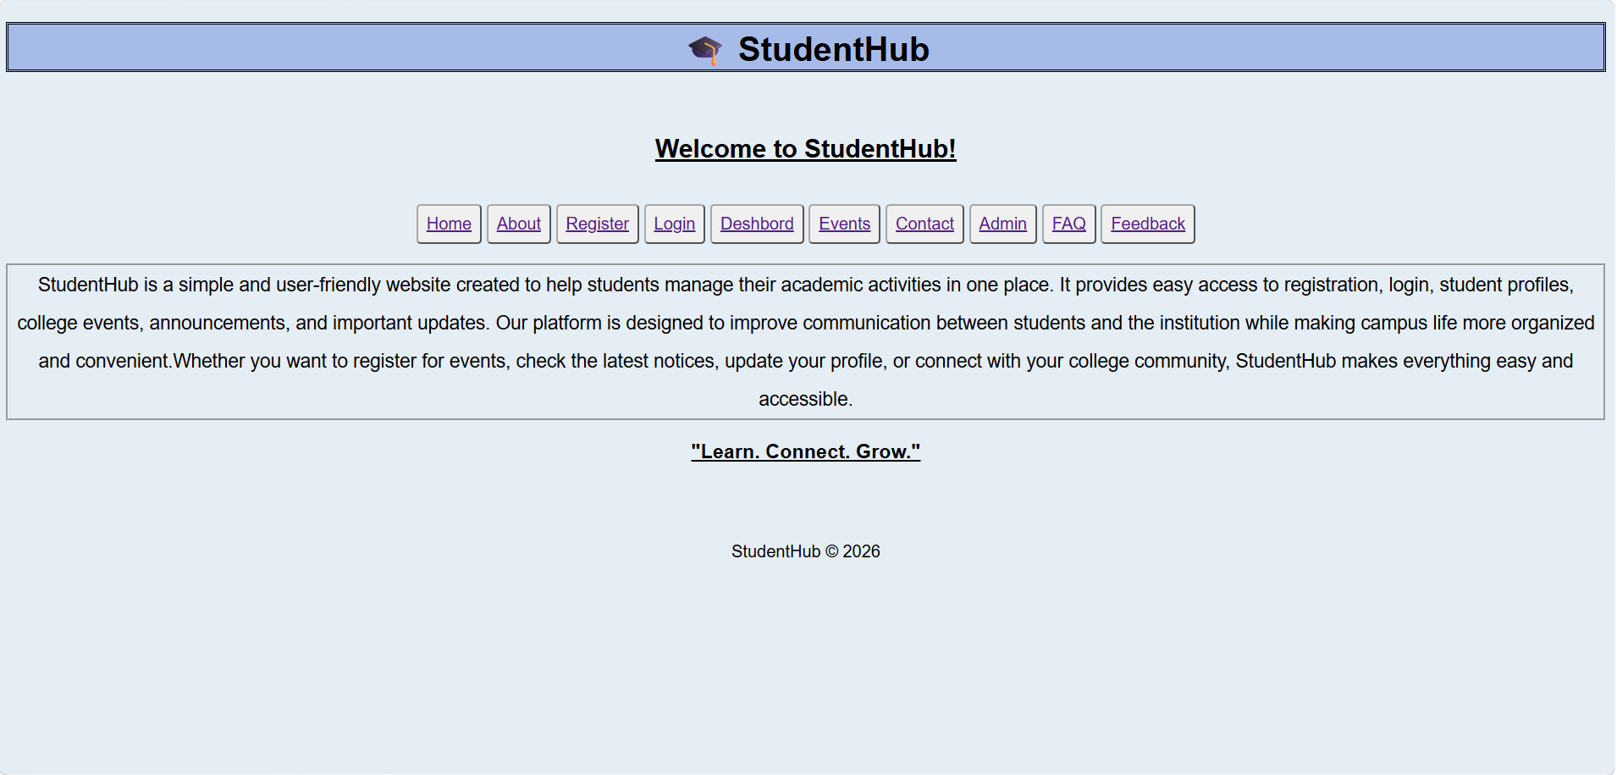

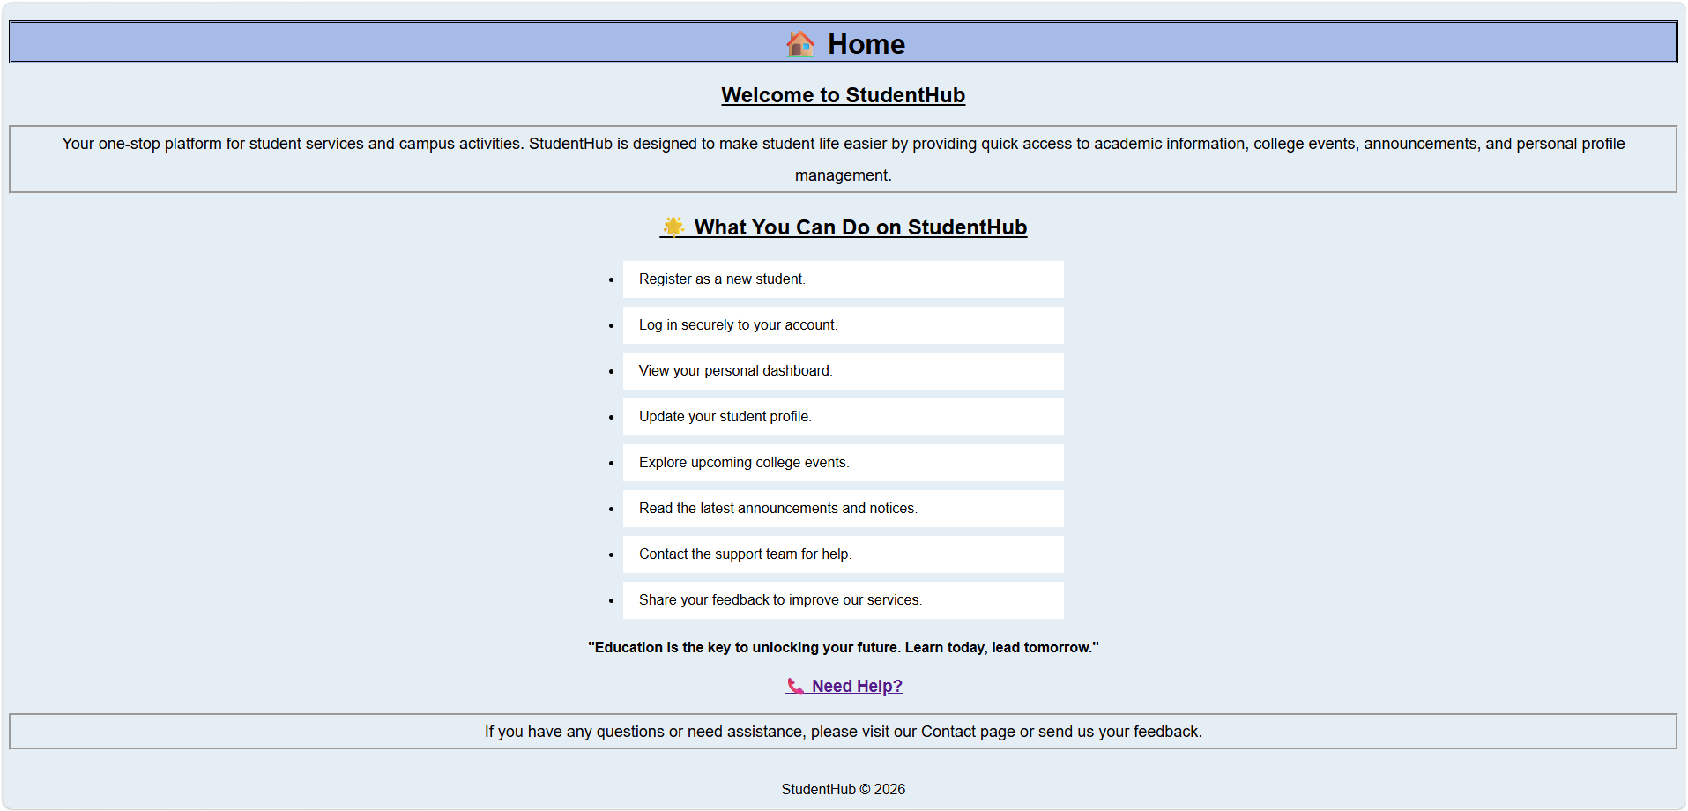

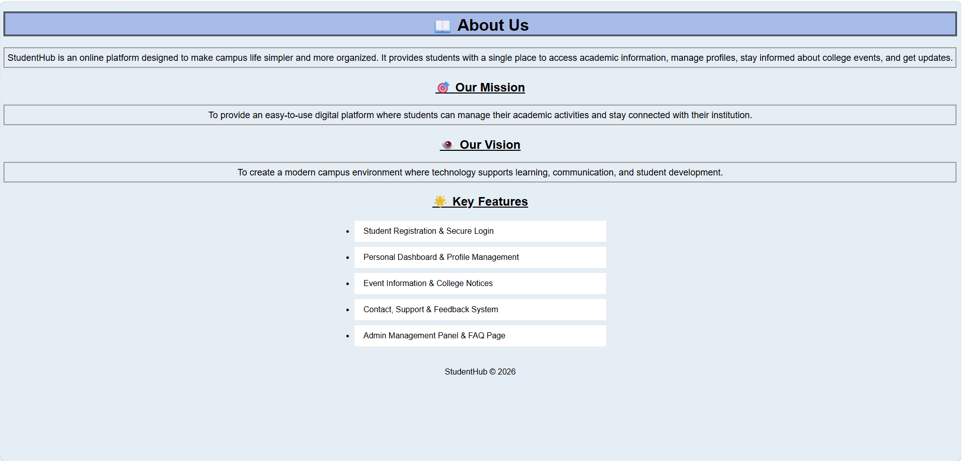

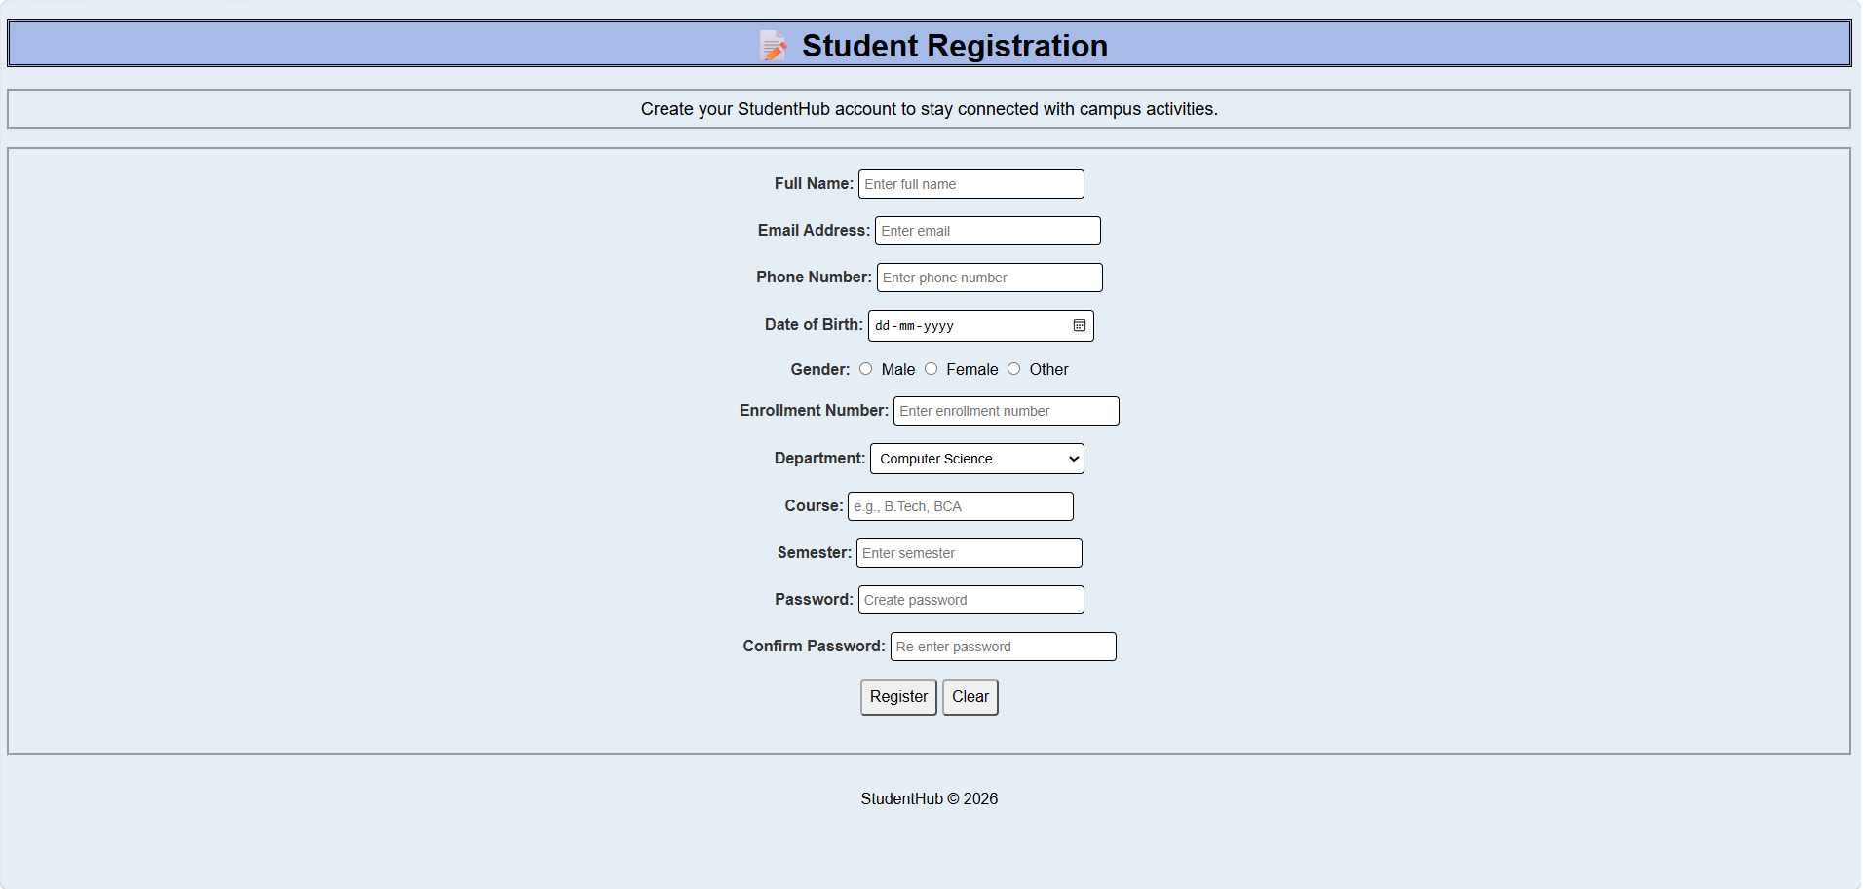

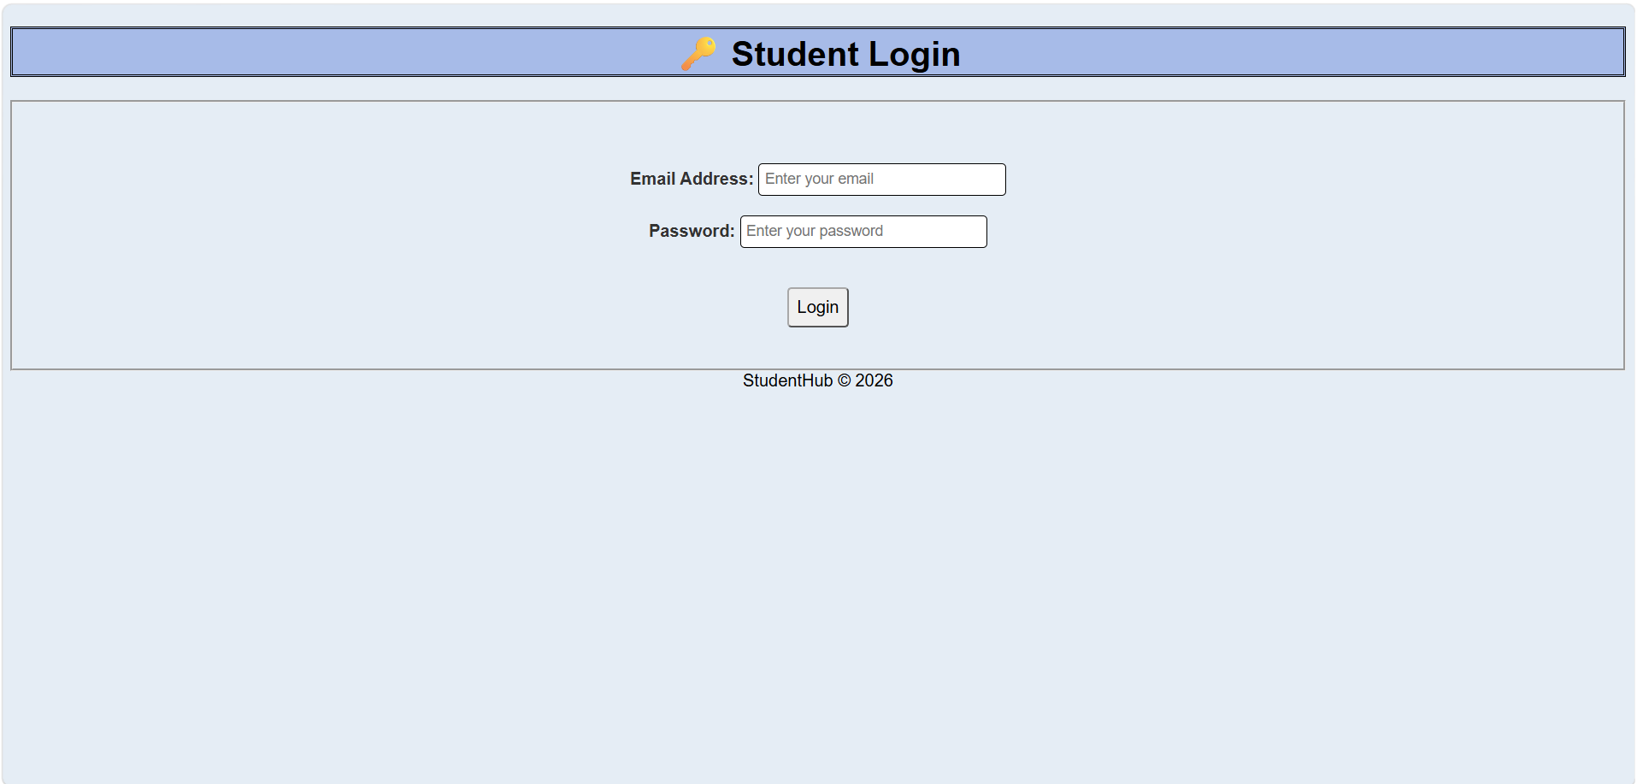

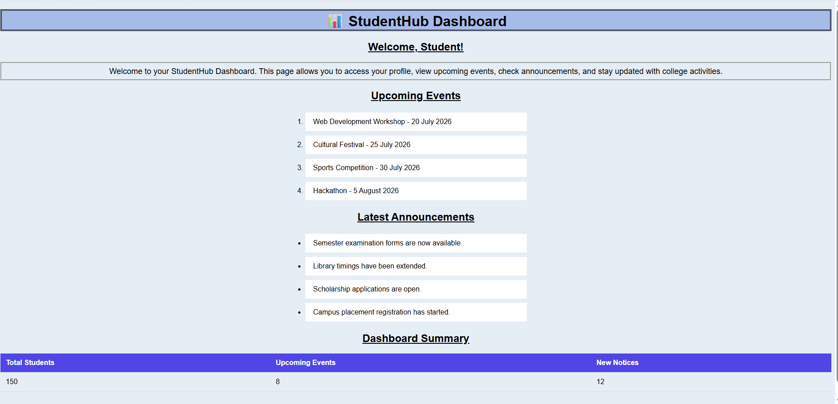

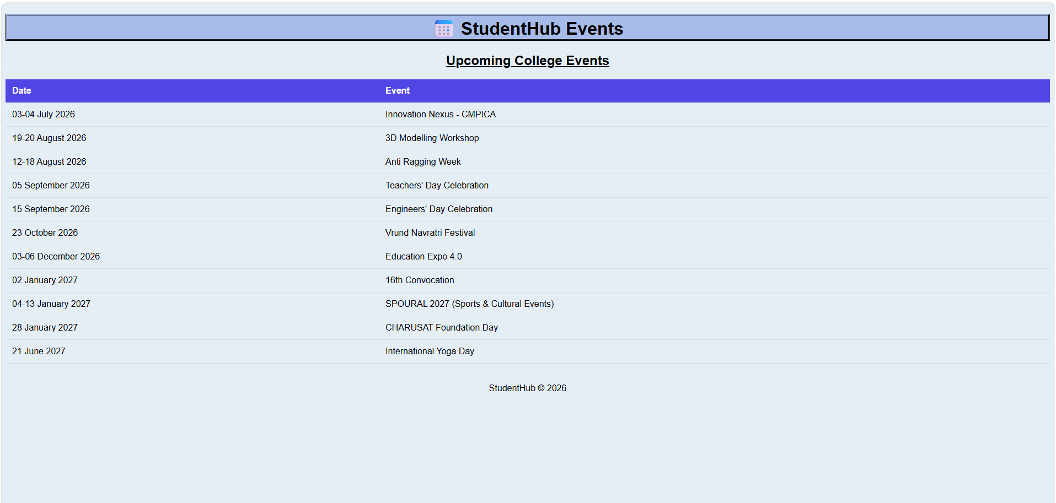

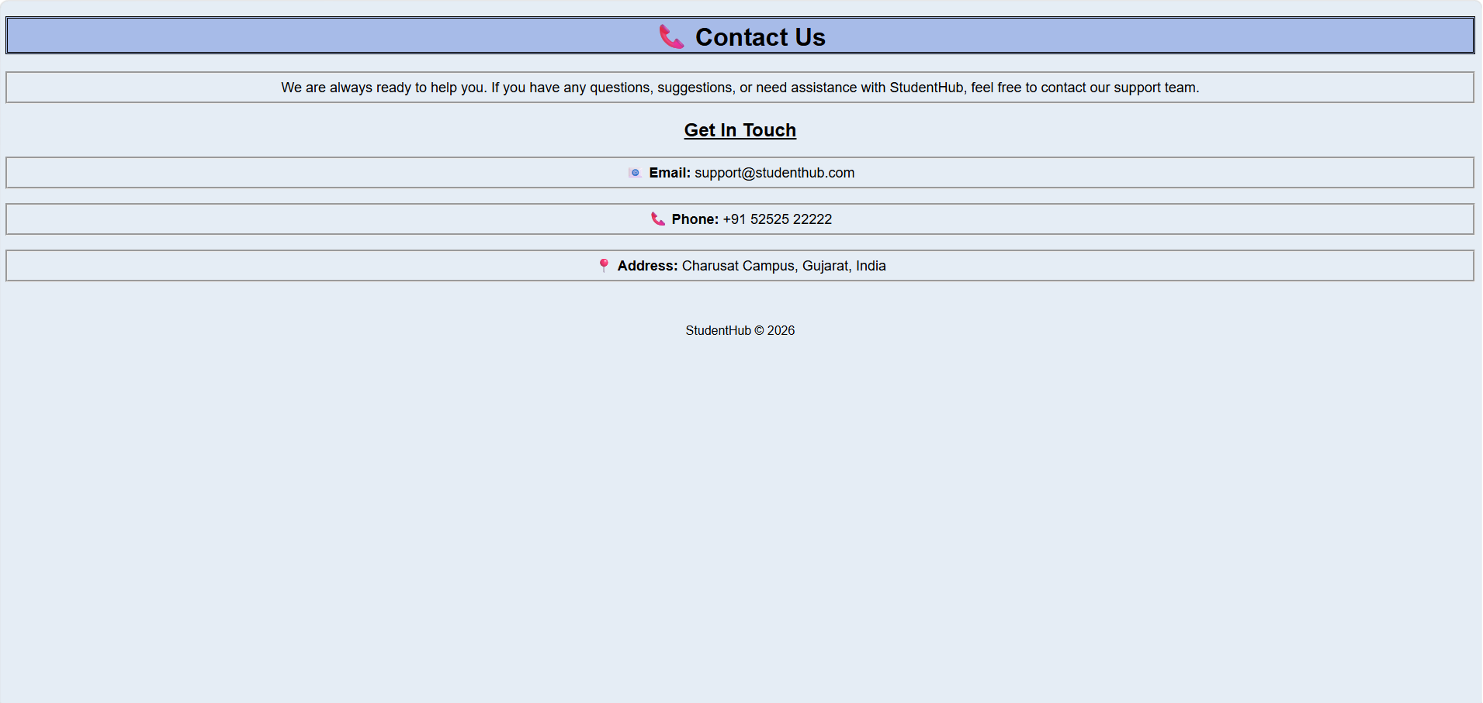

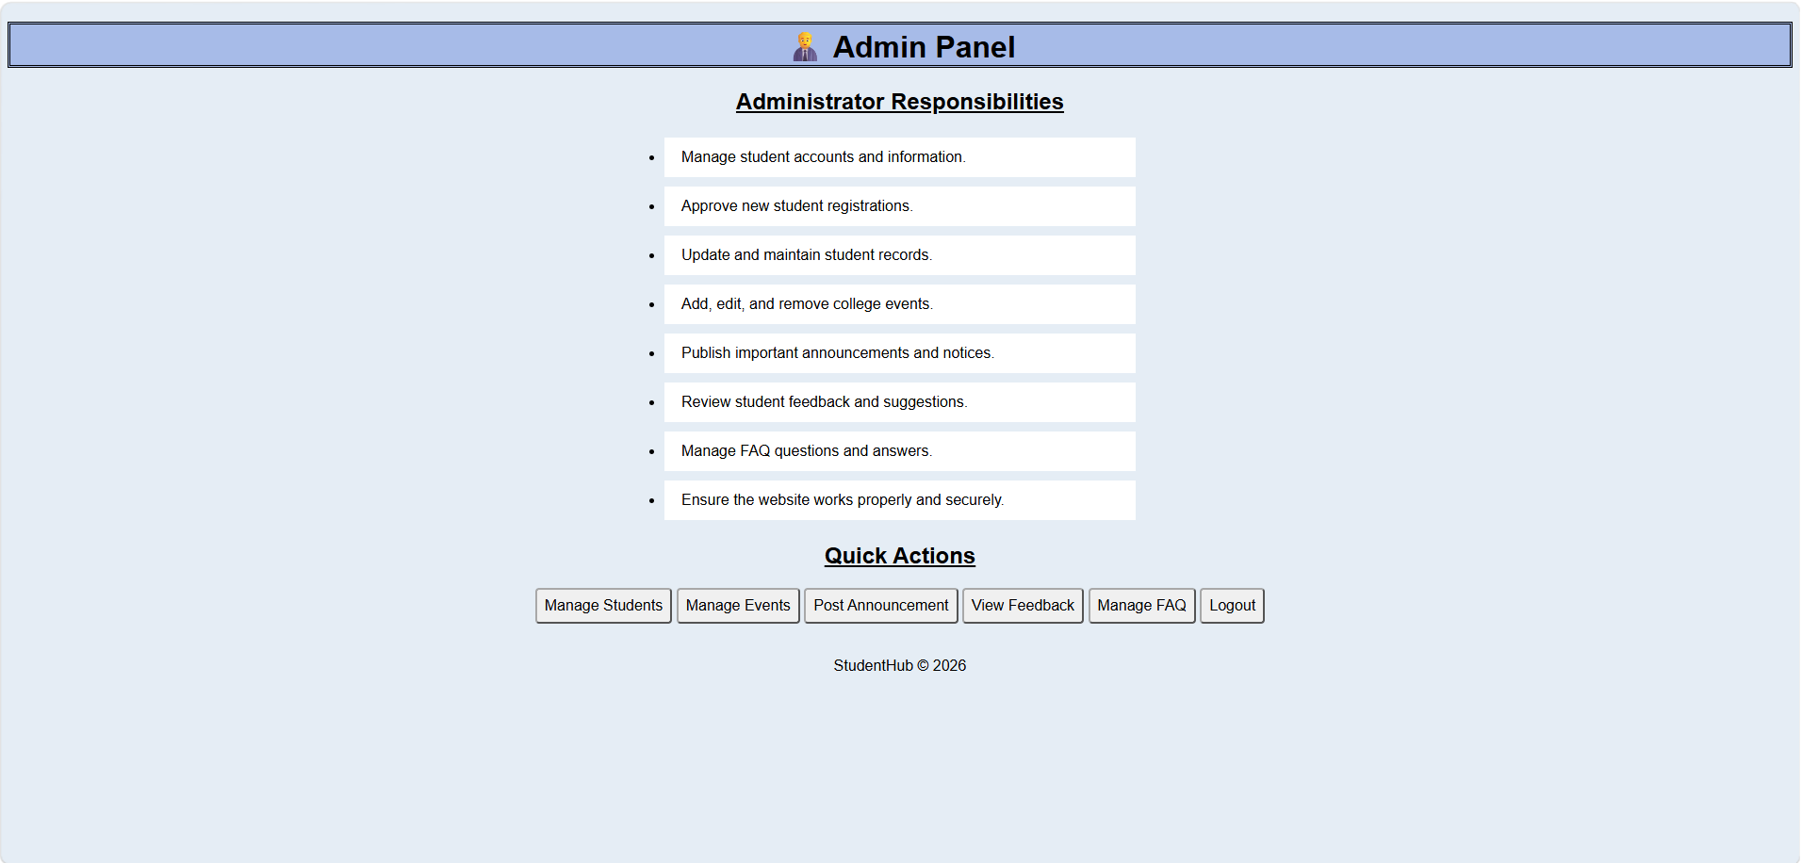

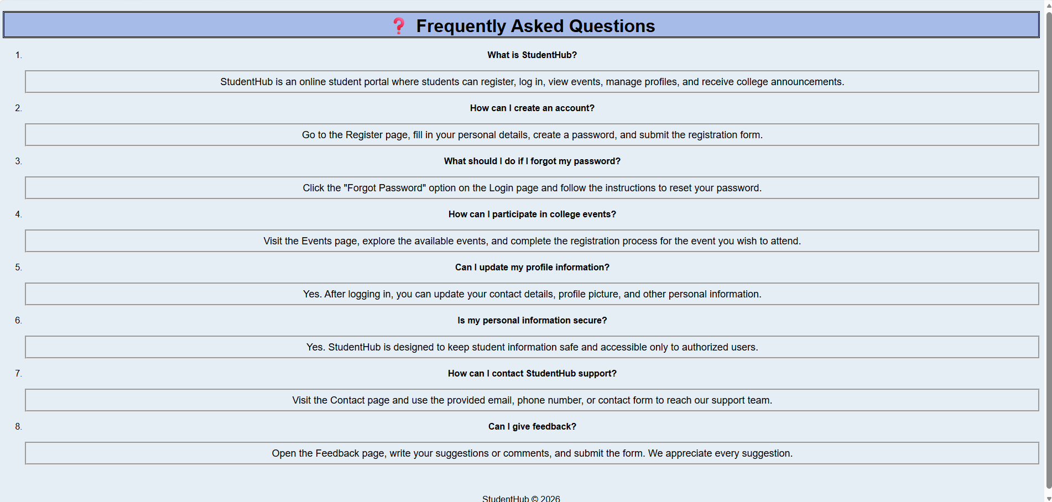

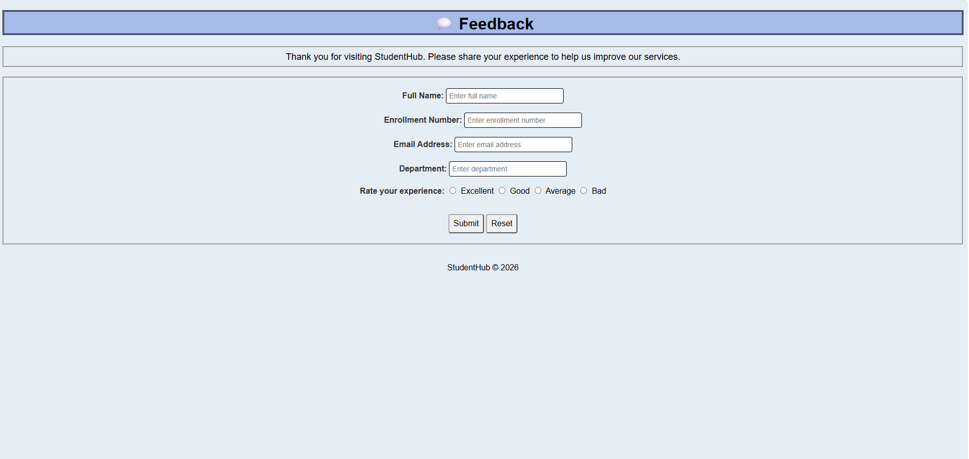

C. GitHub Repository Link:

StudentHub/CSS at main · savaliyariya03/StudentHub

D. Challenges Faced:
Faced difficulty in making the website responsive for different screen sizes.
Learned how to use CSS elements properly.
Fixed layout and spacing issues using media queries.
Ensured all pages displayed correctly on mobile, tablet, and desktop devices.

E. Learning Outcomes:
Learned the concepts of responsive web design.
Understood the use of CSS in website.

F. Faculty Remarks:

